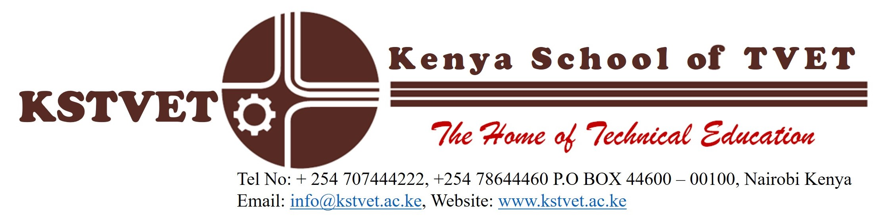

KTTC/ED/RL/56
20th December, 2022

TO WHOM IT MAY CONCERN
SUBJECT: RESEARCH

Students Name ……………………………………………………………………………………..
ADM. NO ………………………………………………………………………………………….
The above named is a student of Kenya School of TVET.
He/She is carrying out a Research in partial fulfillment of the requirement for the award of a Diploma in Technical Education. The Title of his/her research proposal is:

………………………………………………………………………………………………………………………………………………………………………………………………………………………………………………………………………………………………………………………………………………………………………………………………………………………………………………………………………………………………………………………………………

Your assistance and support in the data collection process will be highly appreciated.

Yours faithfully

DR. RUTH GITONGA
HEAD OF EDUCATION & TRAINING DEPARTMENT

